**VILLAGE OF BALDWINSVILLE**

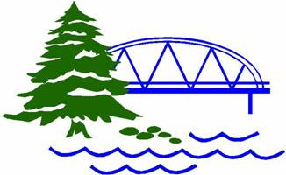

**16 West Genesee Street**

**Baldwinsville, NY 13027**

**Phone # (315) 635-2481 ~ Fax # (315) 635-9231**

**E-mail:** [**codes@baldwinsville.org**](mailto:codes@baldwinsville.org)

**Website: www.baldwinsville.org**

Monday, November 18, 2024 @ 7:00 PM

ARCHITECTURAL REVIEW BOARD AGENDA

Pledge of Allegiance

Approve Minutes from November 4, 2024

**Old Business:**

* Fobes Island PDD – Review project

**New Business:**

* none

***The next meeting date is Monday, December 9, 2024, ~***  
***Application/Submission deadline is November 25, 2024***